Nepal College of Information Technology
Assessment Fall 2013
Program : BE ELX Time : 3 hrs
Semester : Fall (V) FM : 100
Subject : Signal & Systems PM :50

- Candidates are requested to give their answer as far as practicable in their own words.
- The figure in the margin indicates the full marks
- Attempt ALL question
1. | a. | Differentiate the following signals with suitable example:  - Deterministic and Non deterministic signal  - Energy and Power signal  Unit step and Unit impulse | 7
 | b. | Define odd and even signals. Derive any arbitrary signal in terms of its odd and even signal. | 8
2. | a | Obtain Fourier series representation of following signal  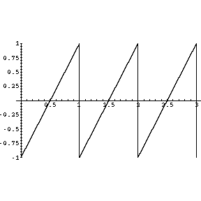 | 8
 | b. | Sketch the following signal: | 7
3 | a. | Find the Fourier transform of a rectangular pulse having width of and height A | 8
 | b. | Define zero padding. Find the circular convolution of following two sequences:  and | 2+5
4. | a. | State and prove Parseval’s Energy theorem for a finite energy signal | 7
 | b. | Find the DFT of following signal using DITFFT | 8
5. | a. | Find the response of the system if it has impulse response and input | 7
 | b. | Define linearity and time invariance of a LTI system. Also check the system  - Memory  - Stability | 8
6. | a. | Describe Distortionless transmission system and also find out the frequency and phase response of such system. | 7
 | b. | Construct Direct form I and Direct form II structure of following transfer function | 8
7. |  | Write short notes on any two:  - Shifting property of impulse function  - Cross correlation and auto correlation  - Speed improvement factor of FFT | 2*5

